WPI Suite

Requirements Management

User Manual

Team 4: Dragon Sparkles

“To develop a requirements management tool which is lightweight and user friendly, and facilitates collaboration and organization for team projects”

Edit:

To develop a simple, user friendly requirements management tool which facilitates process and organization for large projects

Table of Contents

**About**

**General use**

Viewing All Requirements Navigation

View and Edit Existing Requirements

Editing Multiple Requirements at Once

Pie & Bar Chart

Transaction Log

**Project manager**

Adding an Iteration to the Current Project

Edit Requirements

Requirement Status

Entering a Requirement’s Estimate

Estimate Several Requirements

Schedule Several Requirements to an Iteration

Assigning Permissions to Team Members

Unscheduling a Requirement

**Development team member**

Adding a Note to a Requirement

Sub Requirements

Attach an existing requirement as a sub-requirement to a requirement

Slit a Requirement

Acceptance Tests

**Customer**

Creating a Requirement

Deleting a Requirement

Closing a Requirement

Unscheduling a Requirement

Sub Requirements

Scheduling a Requirement for an Iteration

Schedule several requirements to an Iteration

Acceptance Tests

About WPI Suite Requirements manager

WPI Suite Requirements Manager is a tool for college computer science students and professors. Students can use the tool to manage the tasks assigned to them by their professors and organize them into iterations. Professors can use WPI Suite Requirements Manager to delegate projects to teams in the form of tasks, or requirements, indicating the priority of each requirement. For the list of full functionality, see the table of contents.

WPI Suite Requirements Manager was designed by Wonderproducts Inc, and was implemented by team Dragon Sparkles.

# Wonder Products Inc. Stakeholders

Russel T. Customer, President and CEO

Martin M. Weasel, VP of Marketing

Gonzo N. Propellerhead, Chief of Technical Officer

# Team Dragon Sparkles Members

Haley Andrews, Timothy Calvert, Timothy DeFreitas, Alexander Henning, Christian Manuel, James Megin, Glen Modica, Joshua Morse, Deniz Ozgoren, Jacob Palnick, Visit Pataranutaporn, Cynthia Rogers, William Terry, Christina Webb, Sergy Zolotykh

# Coach

Andrew Hurle

General Use

These are features that every user has access to when using WPI suite.

## View all Requirements Navigation

When you first open WPI Suite Requirements Manager, you will be greeted by this screen:

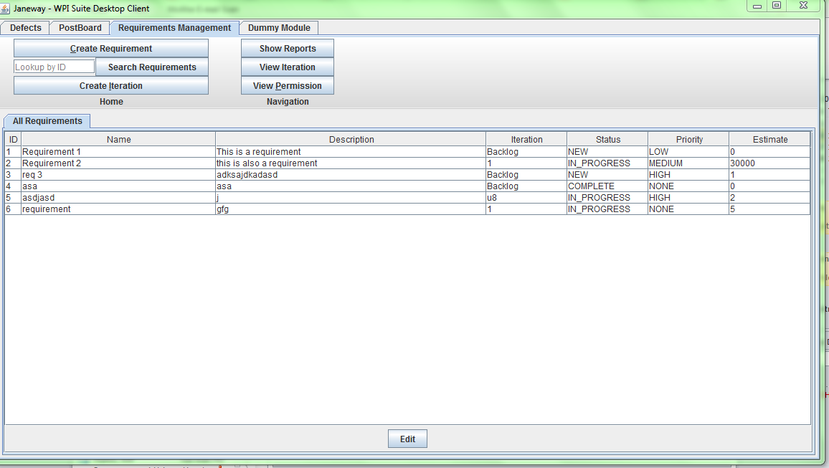

From here, you can view all of the previously created requirements assuming you have permissions to do so. To return to this tab from another tab, click the tab icon “All Requirements” and you will be brought back.

Note that any requirements that have been deleted will not show up on the “All Requirements” view.

## View and Edit an Existing Requirement

Users with the right permissions (as assigned by the Project Manager) can view and edit a requirement in WPI Suite Requirements Manager.

You can view an existing requirement and the notes associated with it through multiple avenues.

To view a requirement in full from the “All Requirements” view. Double click the requirement’s name in the requirements list. A new tab will pop up. Another way is to access a requirement’s Edit view is by typing that requirement into the text box to the right of “Search Requirements” and searching for it. This is handy if you have many requirements in your project.

If the project manager has not assigned you permissions yet, then you can only view the requirement, but if you have permissions in full, then you can edit the requirement fields as shown below:

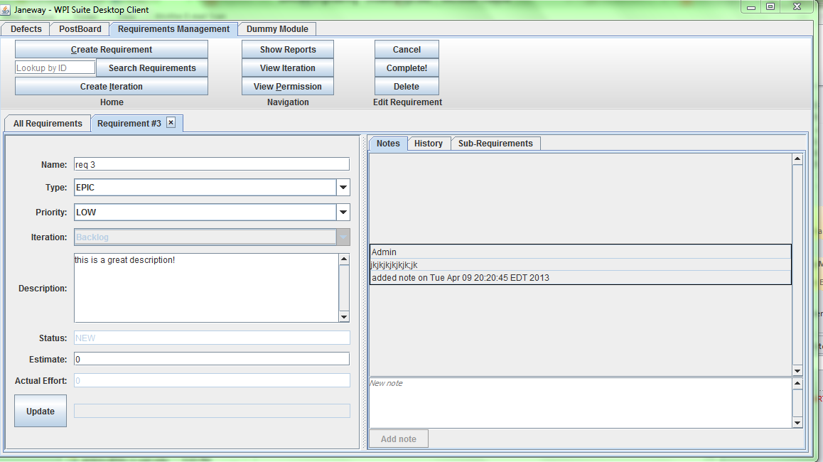

From the edit view, you can edit the requirement’s name, type, description, estimate and actual effort. You can also add a note on the right hand side of the screen which will be saved with the requirement for every time you open the requirement again to view.

### Editing Multiple Requirements at Once

For the purpose of being able to edit multiple requirements at once, there is also an “edit” button at the bottom of the “All Requirements” view. Once you click this button, you will have the ability to edit the fields on that view. Any changes you make on this view must be legal (i.e. You cannot leave the field blank and it must be of a valid value type) and any illegal changes will be highlighted red and will not be saved. The changes you have made will be highlighted yellow until you click the “Save” button at the bottom where the values will be stored and it will return to the original un-editable view.

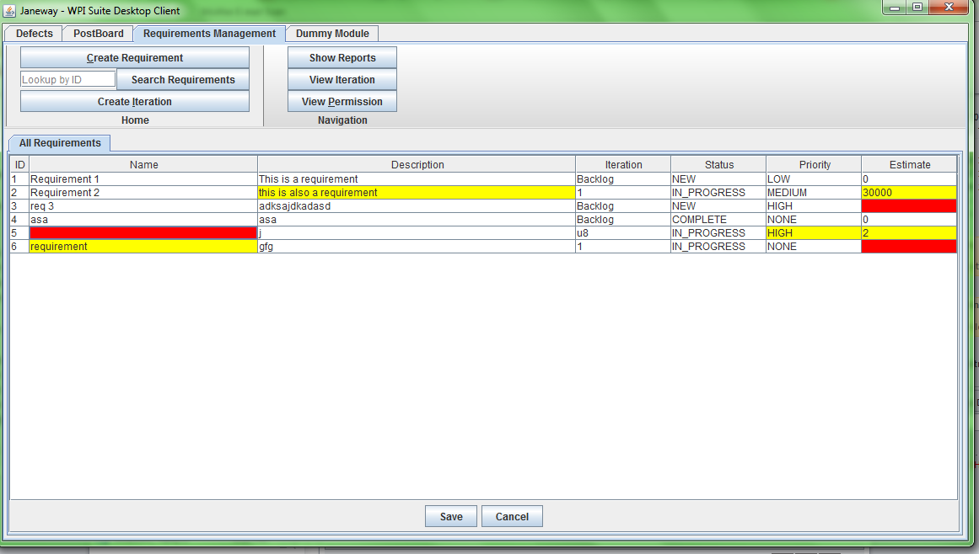

### 

### Pie & Bar Charts

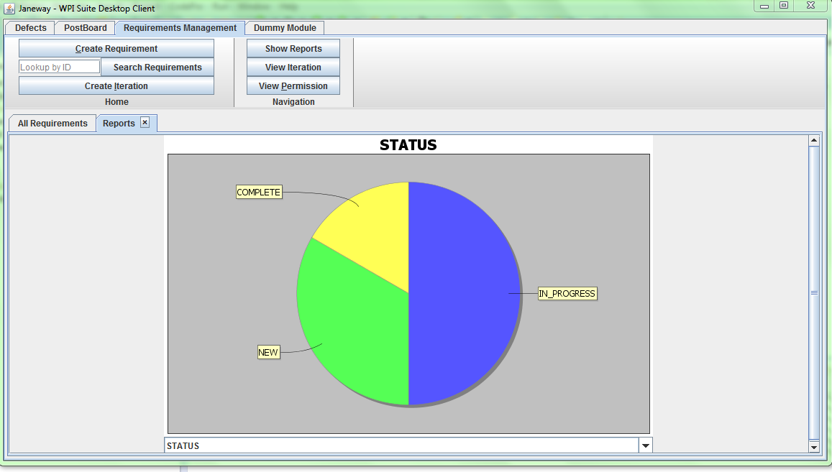Users can comparatively view the number of requirements with a particular status, iteration or member assigned to it. To access the Pie Chart,

#### 

## Transaction log

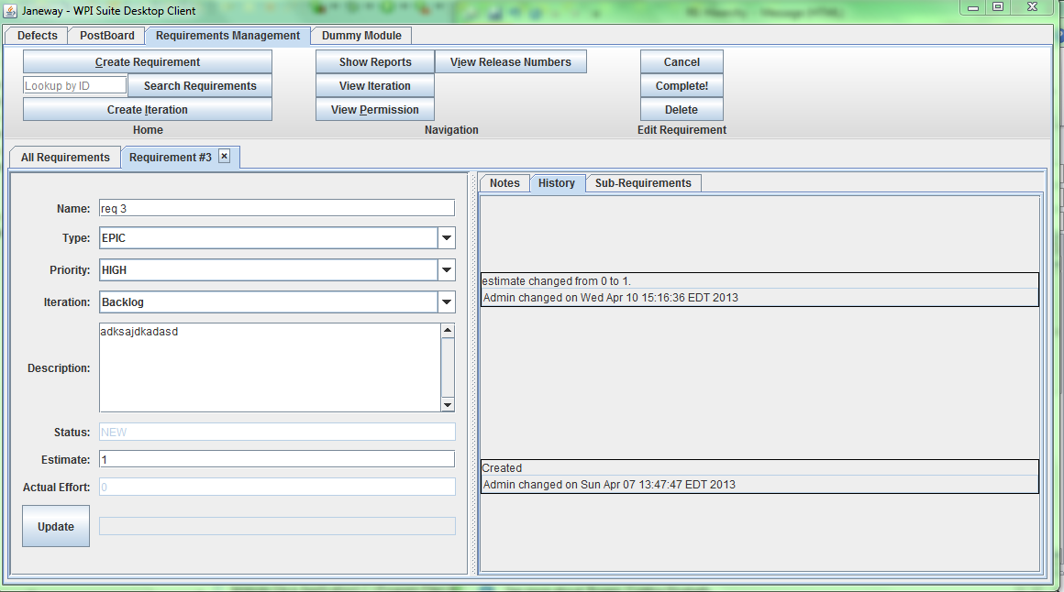Changes make by users to any requirement are tracked in the Transaction Log. Users can access this transaction log by double-clicking on the requirement from the “All Requirements” view to open it in edit mode, and then changing the tab on the right hand side from ‘Notes’ to ‘History’. Each log will track which object was modified, who made the change, what field was changed, when the change was made, the previous value and the new value.

Project Manager

Below are functionalities that the Project Manager will have access to. These abilities stack on top of functionalities in the general use section

## Add an iteration to the current project

As a project manager I want be able to add an iteration to a project so that we can assign requirements for completion in that iteration and the development team can begin to work on the requirements when the iteration is in progress.

Scenario: Add an iteration to a project

Given that I have permissions to edit a project,

When I select "add iteration",

And enter an iteration number (positive integer),

And enter a start date, and end date,

And the start date is not later than the end date,

And the dates do not overlap the date of any other existing iteration,

Then the iteration is added to the project and may be used for scheduling purposes.

Details:

* Overlap of dates means that there is not a day in the iteration you are adding that is inside of another iteration. One iteration may have its start date the same as another iteration's end date however. This indicates that the earlier iteration ends on that day and work starts on the next iteration the same day. Typically, one would make these a day apart.

## Edit Requirements

### Change a requirement’s status

Requirements go through a sequence of states that correspond to the status of the requirement. A team member can make a change to the status according to the following transitions:

1. When a requirement is created, the status is New.
2. When a New requirement is assigned to an iteration the status becomes In Progress.
3. When an In Progress requirement returns to the backlog (the iteration is removed), the status becomes Open.
4. An Open requirement goes to In Progress when it is assigned to an iteration.
5. An In Progress requirement goes to Complete when it the customer accepts it.
6. A Complete requirement can be returned to Open or In Progress.
7. A requirement in any status can be changed to Deleted.
8. A Deleted requirement can be changed to Open or In Progress or Complete.

### Enter a requirement estimate

As a project manager I want to enter the estimate for a requirement so that it can be prioritized and scheduled by the customer. The team should have arrived at an agreed upon estimate for the work before I enter it into the system.

### Estimate Several Requirements

TODO

### Schedule a requirement for an iteration

As a requirements specifier, I want to schedule a requirement to be completed in an iteration so that the development team can work on it.

Scenario: Schedule a requirement

Given that I am editing a requirement,

And the requirement has a positive value for estimated effort,

When I enter a valid iteration for the requirement,

And the iteration is either currently in progress (today is within the iteration's dates) or the iteration is in the future,

And select "update",

Then the requirement will be scheduled for the iteration specified,

And the requirement's estimated effort will be rolled up into the iteration's total estimated effort.

Details:

* The iteration must be defined for the current project.

## Assign requirements management permissions to users

As a WPI Suite project manager  I want to be able to assign permissions to a team member to indicate the permissions that member has for working with requirements in the WPI Suite RM module.

Given that I have permissions to update user permissions on the current project,

When I select a team member,

And assign a requirements permission level,

And select "Update",

An a project log record will be written indicating that I made the change to that persons permissions, showing the old and new permission level.

Details:

Permission levels are:

* None: the person can only see requirements in the project, but do nothing else.
* Update: the person can update the actual effort (if they are one of the team members to whom this requirement is assigned), add and edit notes, add and edit tests, add and edit tasks.

Administer: this person can do anything previously specified, as well as schedule, and change the state of the requirement.

## Unschedule Requirement

As a project manager or customer, I need to unschedule a requirement. This means that I move it to the backlog. This lets me keep the schedule up to date.

When I select the requirement and make the iteration empty (blank), then the requirement is moved from any view of that iteration and will appear in the backlog. No other change is made to the requirement. A history transaction entry is created for the requirement showing that I made the change and the original iteration value and the new iteration value (blank / backlog).

Development Team Member

Any member of the Development team will have access to these features depending on their permissions level as set by the PM. Here is a technical explanation of how to use the Requirements Manager, whereas the same requirements under customer provide an explanation as to the overview of the requirement and use for a customer.

## Add a note to a requirement

As a team member I want to add a note to a requirement. This will let me provide details that are not in the basic description of the requirement. It may be a note about a decision made during a conversation or an insight or design decision.

After adding the note, it will be added to the collection of notes associated with the requirement. Anyone viewing the user story will be able to see this, as well as other notes.

After adding the note, a history log record will be added to the requirement indicating that I added the note.

## Sub Requirements

The top view is whatever children the requirement has. The bottom is a list of the rest of the requirements. When you add a requirement as a child to the selected requirement in this view, then the box near the update button lets you know that it was added to the parent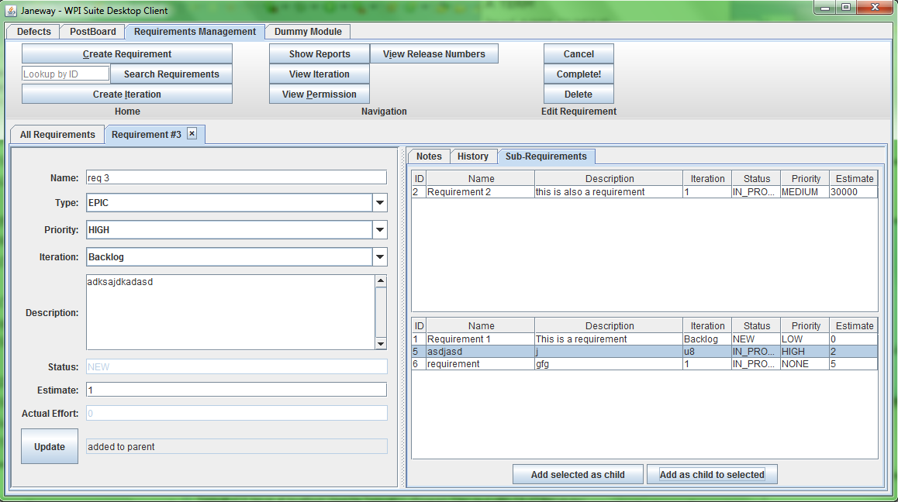

### Attach an existing requirement as a sub-requirement to a requirement

TODO

### Slit a Requirement

TODO

## Acceptance Tests

TODO

Customer

## Creating a Requirement

The user has the ability to create a requirement that specifies a specific feature that the user wants the system under development to have. This allows for the creation of correct marketing materials while ensuring that the detailed requirements and tasks support the planned features. Once a requirement is saved, it becomes part of the current project, is assigned a unique **ID** number, the **Status** is set to “NEW”, a **transaction** is entered into the requirement’s history, or **Transaction Log**, and the requirement is now available for retrieval**/viewing**  and **editing**.

How to Create a Requirement

1. Click the “New Requirement” button at the top of the window
2. Enter a **Name**, **Description**, and any **optional fields**
3. Click the Save button

* **Fields:**
  + **Name:** This is the name of your requirement. It can be up to 100 characters long but cannot be left blank
  + **Iteration**: This is the time period that the requirement will take during. See **Creating an Iteration** for more details
  + **Description:** This tells the user a summary of the specifications for your requirement. It is virtually unlimited in size but cannot be left blank
  + **ID**: This is a string of characters that is unique to each requirement. This makes it easier to reference
  + **Status**:The status is the state the requirement is currently in. It can be **Edited** once the requirement has been created. See **Changing a Requirement’s Status** for more details
  + **Optional Fields:** This includes the **Release Number**, **Type of Requirement**, and **Priority**
    - **Release Number:** This is one of the optional fields. If it is entered, it must be one of the release numbers in the current project. If the project already has a current release, the requirement’s default release number is the same as this. This may be overridden, including the option to not have a release number at all.
    - **Priority:** This is one of the optional fields. It is by default blank, or the user can decide to set it to High, Medium, or Low. See **Setting the Priority** section for more details.
* **Transaction**: Each time a change is made (whether it is creating a requirement or editing any of its fields), a record is added to the requirement’s **Transaction Log**. See the **Transaction Log** section for more details.
* **Transaction Log**: This is a complete record of all changes (“transactions”) that have been made to a particular requirement. See the **Transaction Log** section for more details.
* **Viewing:** Once a requirement has been created, it can be retrieved and viewed from the **All Requirements** view. See the **Viewing All Requirements** section.
* **Editing:** Once a requirement has been created, it is available for editing. Double clicking on a specific requirement allows editing of all fields the user has **permission** to edit. Highlighting several requirements, clicking on the “Edit” button, and changing the fields will allow the editing of multiple requirements. For more information, see the **Permissions**, **Editing a Requirement**, and **Editing Multiple Requirements** sections.

Details:

* Requirements may contain other requirements. These are sub-requirements that must be satisfied (completed) in order for the containing requirement to be considered satisfied. Initially, this is an empty set.
* Requirements may also contain notes. How these are use is up to the end user. Initially, a requirement has an empty set of notes.
* Requirements may be scheduled for an iteration. By default, the iteration is empty.
* Requirements have an actual effort value associated with them. This value is initially zero.
* Requirements may be assigned to zero or more team members. Initially, this is an empty set.
* Requirements have a estimate associated with it. This is a non-negative integer value. Initially, the value is zero.
* Requirements have development tasks associated with them. Initially, this is an empty set.
* Requirements have acceptance tests associated with them. Initially this is an empty set.
* Requirements have attachments associated with them. An attachment can be any file such as an image, archive, and so on.
* Requirements have a history (log) associated with them. Each history / log record indicates a change to the requirement. All log records have a timestamp, user who performed the action, and text indication the action.

## Delete a requirement

As a project manager or requirements specifier I want to remove a requirement form the system because is is no longer a needed requirement.

Scenario: Remove a requirement with no sub-requirements or developer tasks in progress

Given that I am viewing a requirement and can delete it,

And the requirement has no sub-requirements,

And there are no open tasks associated with the requirement,

And the requirement status is not In Progress,

When I select "Delete",

Then the requirement status will be changed to Deleted,

And a history transaction will be created showing that I deleted the requirement,

And no other changes can be made to the requirement unless it is changed back to an Open status.

## Close a requirement that has no sub-requirements

As a customer, I want to accept that a requirement has been completed so that the team gets credit for completing the work. When I do this, the requirement is considered complete. Typically, this will be because the team has demonstrated than any acceptance tests pass or that they have tested the system for the correctness according to the requirement and demonstrated to me that the requirement is complete.

Given that I am viewing a requirement,

And I have privileges to change its status,

When I change the requirement to complete,

And select "update",

Then the requirement's status will be Complete,

And no other changes can be made to the requirement unless it is to delete it or re-open it,

And a history transaction will be created indicating that I closed the requirement.

If the requirement has any open tasks, they will be closed.

## Unschedule Requirement

As a project manager or customer, I need to unschedule a requirement. This means that I move it to the backlog. This lets me keep the schedule up to date.

When I select the requirement and make the iteration empty (blank), then the requirement is moved from any view of that iteration and will appear in the backlog. No other change is made to the requirement. A history transaction entry is created for the requirement showing that I made the change and the original iteration value and the new iteration value (blank / backlog).

## Sub Requirements

TODO

### Attach an existing requirement as a sub-requirement to a requirement

TODO

### Slit a Requirement

TODO

## Schedule a requirement for an iteration

As a requirements specifier, I want to schedule a requirement to be completed in an iteration so that the development team can work on it.

Scenario: Schedule a requirement

Given that I am editing a requirement,

And the requirement has a positive value for estimated effort,

When I enter a valid iteration for the requirement,

And the iteration is either currently in progress (today is within the iteration's dates) or the iteration is in the future,

And select "update",

Then the requirement will be scheduled for the iteration specified,

And the requirement's estimated effort will be rolled up into the iteration's total estimated effort.

Details:

* The iteration must be defined for the current project.

### Schedule Several Requirements for an Iteration

TODO

## Acceptance Tests